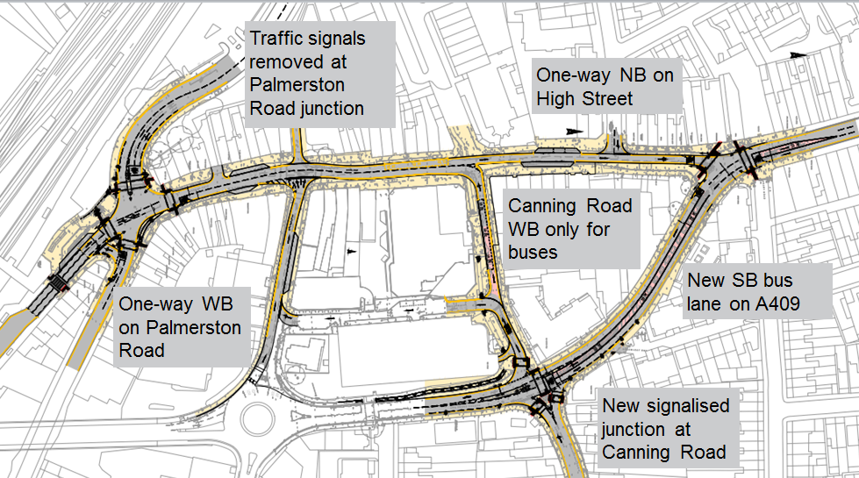

**APPENDIX A – TOWN CENTRE AND BUS IMPROVEMENT SCHEME**

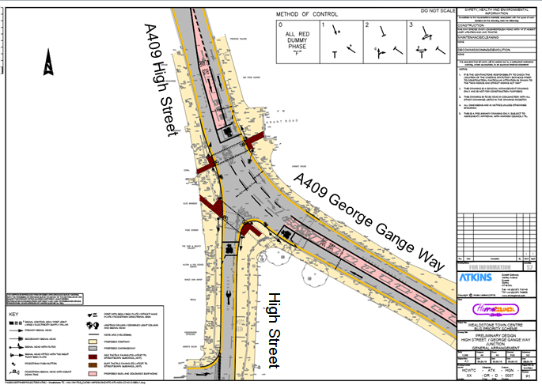 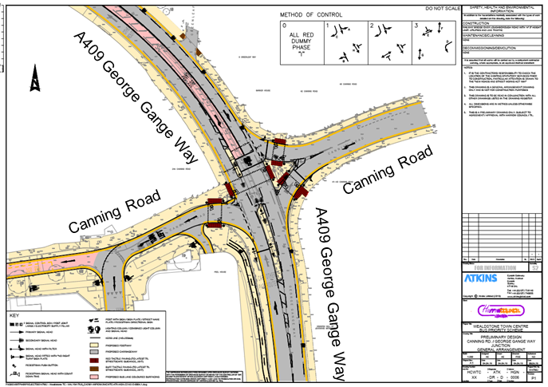

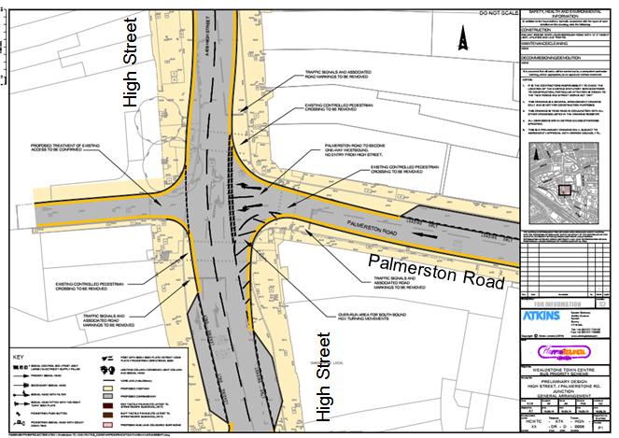 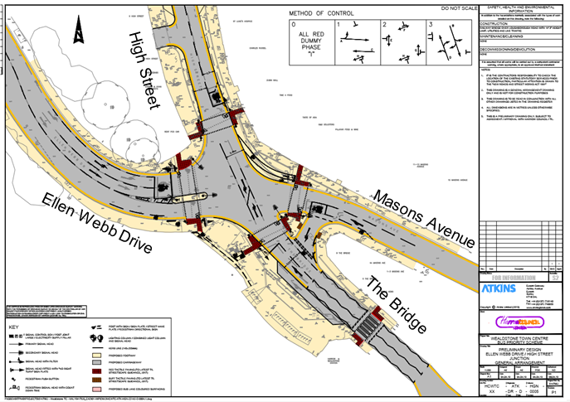

**APPENDIX A – TOWN CENTRE AND BUS IMPROVEMENT SCHEME**

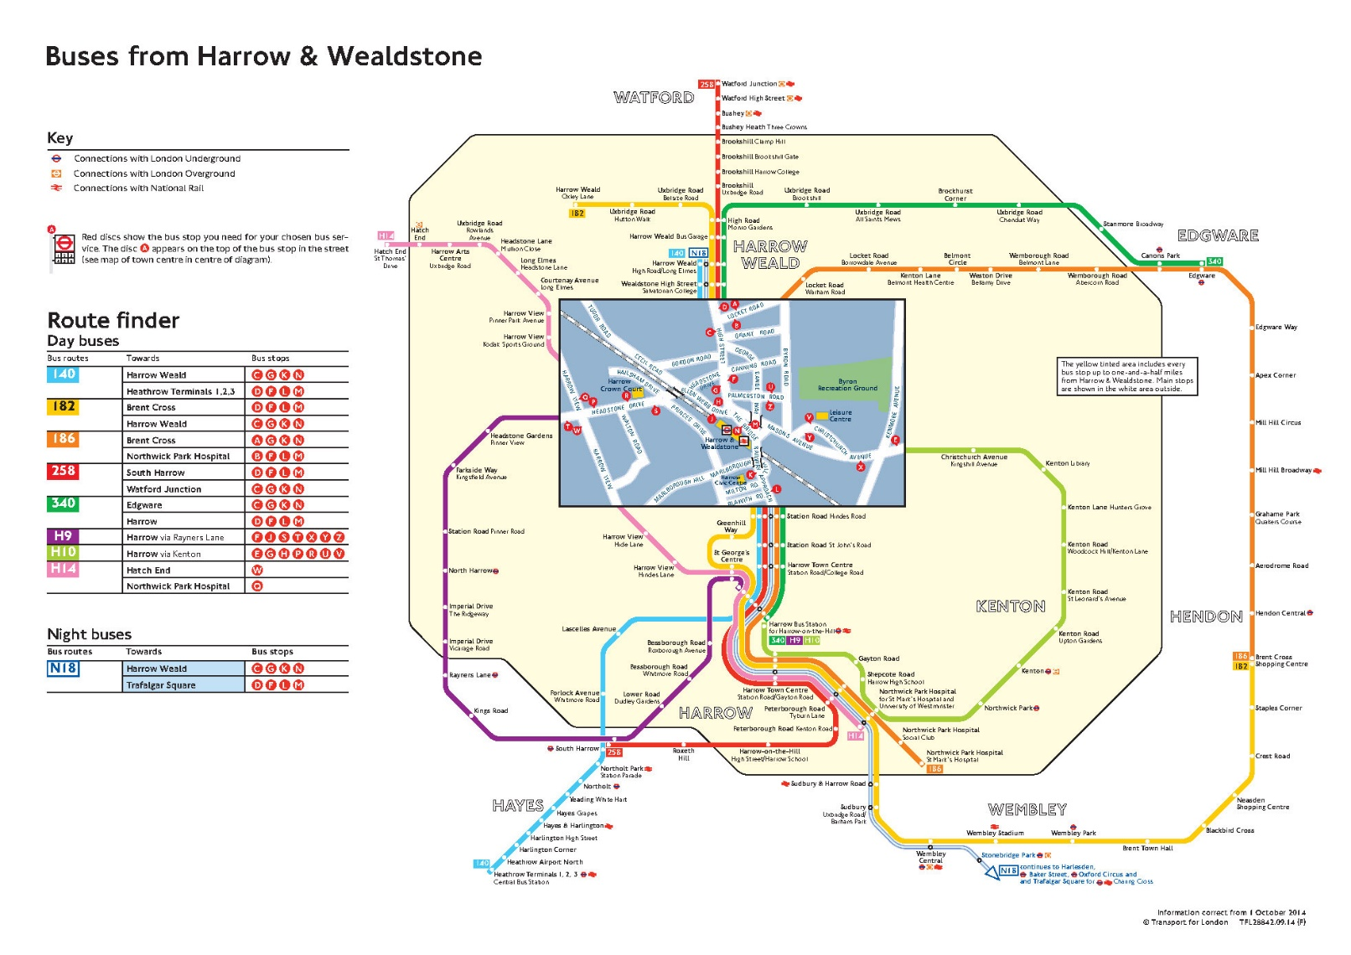

**APPENDIX B – WEALDSTONE BUS NETWORK**

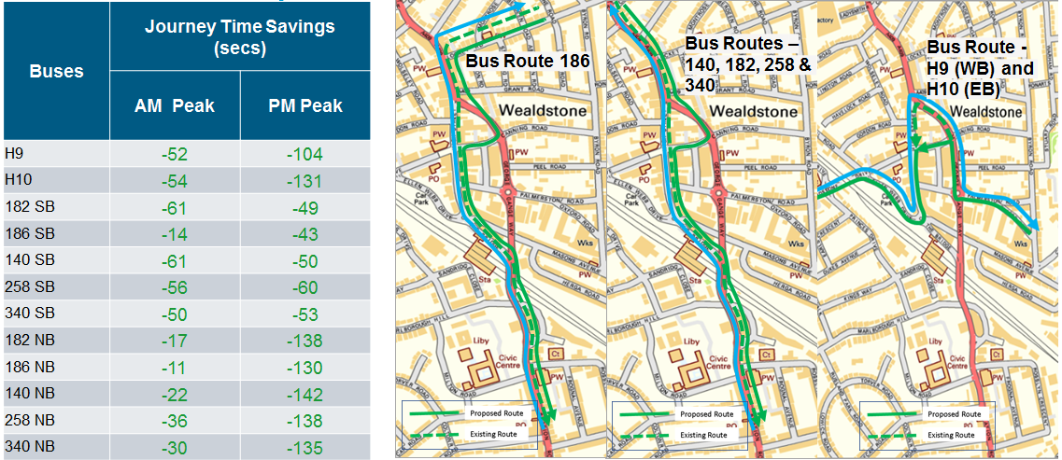

**APPENDIX B – BUS JOURNEY TIME IMPROVEMENTS**